Title of the book: Artificial Intelligence
Type of book: Edited/Authored

Authors: Authors Name, Authors Name, Authors Name

Affiliations: Affiliation, Affiliation, Affiliation

All Authors Email ID (Mandatory): abc@gmail.com, pqrs@gmail.com, xyz@gmail.com

All Authors ORCID IDs (Mandatory): https://orcid.org/0000-, https://orcid.org/0000-0-, https://orcid.org/0000-0

Published, marketed, and distributed by:
Deep Science Publishing, 2026
USA | UK | India | Turkey
Reg. No. MH-33-0658412
www.deepscienceresearch.com
editor@deepscienceresearch.com
WhatsApp: +91 7977171947

ISBN:
E-ISBN:
https://doi.org/10.70593/
Copyright © Authors Name, 2026.
Citation: Surname, N. L., Surname, S. K., Surname, O., & Surname, J. (2026). Book title. Deep Science Publishing.
This book is published online under a fully open access program and is licensed under a Creative Commons Attribution-NonCommercial 4.0 International License (CC BY-NC 4.0). This open access license allows third parties to copy and redistribute the material in any medium or format, provided that proper attribution is given to the author(s) and the published source. The publishers, authors, and editors are not responsible for errors or omissions, or for any consequences arising from the application of the information presented in this book, and make no warranty, express or implied, regarding the content of this publication. Although the publisher, authors, and editors have made every effort to ensure that the content is not misleading or false, they do not represent or warrant that the information-particularly regarding verification by third parties-has been verified. The publisher is neutral with regard to jurisdictional claims in published maps and institutional affiliations. The authors and publishers have made every effort to contact all copyright holders of the material reproduced in this publication and apologize to anyone we may have been unable to reach. If any copyright material has not been acknowledged, please write to us so we can correct it in a future reprint.
Preface
This book offers a comprehensive exploration of the ………..
Author Name
Author Name
Author Name

Table of Contents
Please note: You do not need to prepare the table of contents. It will be handled by our team during the copy-editing stage


Deep Science Publishing, 2026
https://doi.org/

Chapter 1: Chapter title (Size 16)

1 Introduction
The (Size 11, Spacing 1.15, Add space after paragraph)

1.1 Artificial Intelligence
Table 1.1 shows the (Size 11, Spacing 1.15, Add space after paragraph).

Deep Science Publishing, 2026
https://doi.org/

Chapter 2: Kindly read the guidelines provided at the end of this document (Size 16)

1 Introduction
The (Size 11, Spacing 1.15, Add space after paragraph)

1.1 Artificial Intelligence
Table 1.1 shows the (Size 11, Spacing 1.15, Add space after paragraph).

Deep Science Publishing, 2026
https://doi.org/

Chapter 3: You must use the styles given in the Home menu to keep the formatting consistent (Size 16)

1 Introduction
The (Size 11, Spacing 1.15, Add space after paragraph)

1.1 Artificial Intelligence
Table 1.1 shows the (Size 11, Spacing 1.15, Add space after paragraph).

Deep Science Publishing, 2026
https://doi.org/

Chapter 4: You must use the styles given in the Home menu to keep the formatting consistent

1 Introduction
The

1.1 Artificial Intelligence
The

Deep Science Publishing, 2026
https://doi.org/

Chapter 5: You must use the styles given in the Home menu to keep the formatting consistent

1 Introduction
The

1.1 Artificial Intelligence
Table 1.1 shows the

Deep Science Publishing, 2026
https://doi.org/

Chapter 6: You must use the styles given in the Home menu to keep the formatting consistent

1 Introduction
The

1.1 Artificial Intelligence
Table 1.1 shows the

Deep Science Publishing, 2026
https://doi.org/

Chapter 7: Artificial intelligence and machine learning

1 Introduction
The

1.1 Artificial Intelligence
Table 1.1 shows the

Deep Science Publishing, 2026
https://doi.org/

Chapter 8: Artificial intelligence and machine learning

1 Introduction
The

1.1 Artificial Intelligence
Table 1.1 shows the

Deep Science Publishing, 2026
https://doi.org/

Chapter 9: Artificial intelligence and machine learning

1 Introduction
The

1.1 Artificial Intelligence
Table 1.1 shows the

Deep Science Publishing, 2026
https://doi.org/

Chapter 10: Artificial intelligence and machine learning

1 Introduction
The

1.1 Artificial Intelligence
Table 1.1 shows the

Deep Science Publishing, 2026
https://doi.org/

Chapter 11: Artificial intelligence and machine learning

1 Introduction
The

1.1 Artificial Intelligence
Table 1.1 shows the

Deep Science Publishing, 2026
https://doi.org/

Chapter 12: Artificial intelligence and machine learning

1 Introduction
The

1.1 Artificial Intelligence
Table 1.1 shows the

Deep Science Publishing, 2026
https://doi.org/

Chapter 13: Artificial intelligence and machine learning

1 Introduction
The

1.1 Artificial Intelligence
Table 1.1 shows the

Deep Science Publishing, 2026
https://doi.org/

Chapter 14: Template Formatting Guidelines

1 Introduction
The pages size should be set to ISO B5, measuring 176 mm X 250 mm, with margins: Top, Left, Right, Bottom: 20mm. Ensure all the figures and tables cited in the paragraphs. Ensure all the citations listed in the references section. Use Times New Roman of size 11 and spacing 1.15 for text. Use Vancouver citation style (You are also free to use any other citation style) for citations and the reference list.
These technologies adoption and expansion have been accelerated by the rapid advancement of processing power and the wealth of available data [6,7]. The ML and DL architectures, which are the foundation of these technologies, have made significant progress and shown remarkable capabilities in tasks such as natural language processing, autonomous systems, and image and audio recognition. ML models come in a variety of architectures, from basic linear regression models to intricate neural networks, designed for different tasks and types of data [2,8-10].
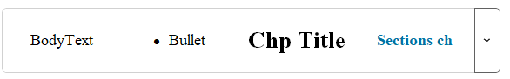
Fig. 1.1 Use styles for QUICK formatting Chapter title, Authors Name, Sections, Sub-section, and Body Text

1.1 Artificial Intelligence
Table 1.1 shows the key architectural innovations and enhancements in ML and DL.

1.2 Machine Learning
Table 1.1 shows the key architectural innovations and enhancements in ML and DL.

2 Literature review
Fig. 1.1 shows the co-occurrence analysis of the trending keywords in ML. Table 1.1 shows the key architectural innovations and enhancements in ML and DL. Ensure that all tables and figures are properly cited within the text.

3 Methods and materials
Fig. 1.1 shows the co-occurrence analysis of the trending keywords in ML. Table 1.1 shows the key architectural innovations and enhancements in ML and DL.

4 Results and discussions
Fig. 1.1 shows the use of styles created for formatting your book Table 1.1 shows the key architectural innovations and enhancements in ML and DL.
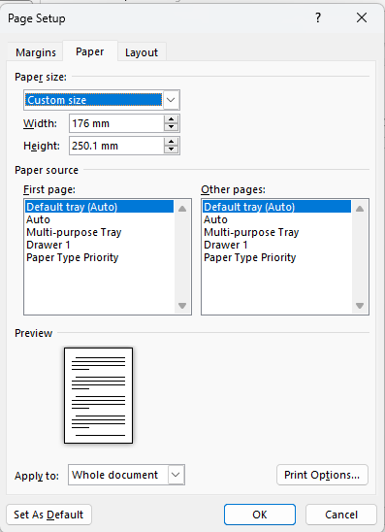
Fig. 1.2 Page size
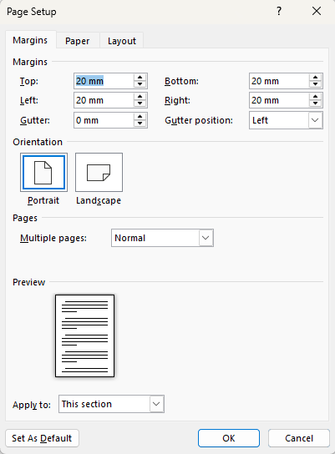
Fig. 1.3 Page margin

Table 1.1 Key architectural innovations and enhancements in ML and DL. Text within tables should be set in size 10.
Sr. No. | References | Architectural Innovation | Description | Enhancements | Key Applications
1 | (Shrestha & Mahmood, 2019; Aziz et al., 2020; Deng, 2014) | Convolutional Neural Networks (CNNs) | A category of deep neural networks predominantly employed for scrutinizing visual stimuli. | Noteworthy advancements encompass. | Disciplines of interest encompass.
2 | (Alzubaidi et al., 2021; Janiesch et al., 2021; Wu & Xie, 2022) | Recurrent Neural Networks (RNNs) | Neural network architectures characterized | Distinctive enhancements embrace proficient handling of sequential datasets. | Application domains.

Conclusions
Transformer-based models such as BERT have caused a significant change in the field of NLP and consistently establish higher levels of performance. These models use self-attention mechanisms to better capture contextual information compared to traditional RNNs and CNNs.

References
- Schintler LA, McNeely CL. Artificial intelligence, institutions, and resilience: Prospects and provocations for cities. Journal of Urban Management. 2022 Jun 1;11(2):256-68. (Size-10)
- Jiang M, Yu X. Enhancing the resilience of urban energy systems: The role of artificial intelligence. Energy Economics. 2026 Apr 1;144:108313.
- Chen E, Zhang H. Research on the impact of artificial intelligence technology on urban public health resilience. Frontiers in Public Health. 2026 Jan 7;12:1506930.
- Chen Y, You W, Ou L, Tang H. A review of machine learning techniques for urban resilience research: The application and progress of different machine learning techniques in assessing and enhancing urban resilience. Systems and Soft Computing. 2026 Apr 29:200269.
- Saravi S, Kalawsky R, Joannou D, Rivas Casado M, Fu G, Meng F. Use of artificial intelligence to improve resilience and preparedness against adverse flood events. Water. 2019 May 9;11(5):973.

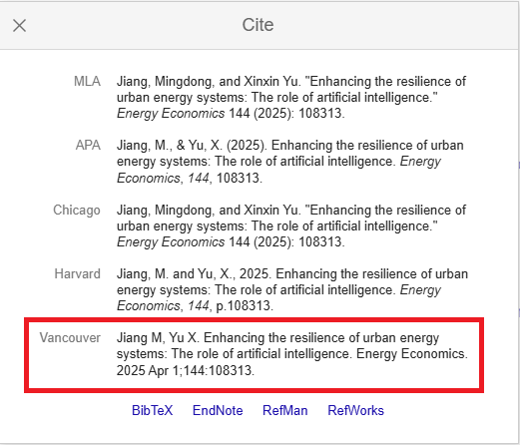
Fig. 1.4 Vancouver Style on Google Scholar. You are also free to use any other citation style.

Manuscript Submission Checklist:
- Page size set to 176 mm x 250 mm?
- Margins: Top, Left, Right, Bottom: 20mm?
- Are all figures and tables cited within the text?
- Are all citations listed in the reference section?
- Text in Times New Roman, size 11, spacing 1.15?

Need Help with Formatting?
If you have any formatting issues or need personal assistance, please email us at editor@deepscienceresearch.com for support.

